The 24v Cummins Injector Bible
By: McGuire Injection

Chapter 1: How to change nozzles in a 24v Cummins

Chapter 2: How changing nozzles will affect popping pressure
Chapter 2a: Measuring the nozzles

Chapter 3: What the injection shop is going to do with your injectors

Chapter 1:

- How to change nozzles in a 98.5-02 24v Cummins injector

Tools:
15mm deep well socket
Torque Wrench
Some type of sheet of metal to hold the injector
Vice

Time: 15-45mins

Skill: Moderate to High

To start off I highly recommend getting your injectors pop-tested after changing nozzles.

After getting your injectors out of your truck find a spot to change your injectors be sure to keep EVERYTHING clean. One piece of dirt that’s .009in in diameter would make a new nozzle worthless.

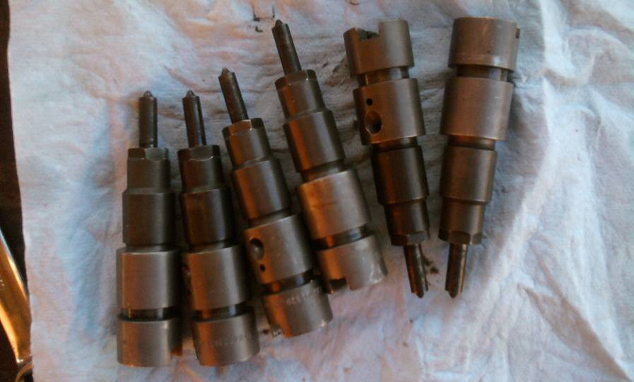

Once everything is clean crack loose the injectors and be sure not to not change any of the parts and replace the old nozzle with the new one.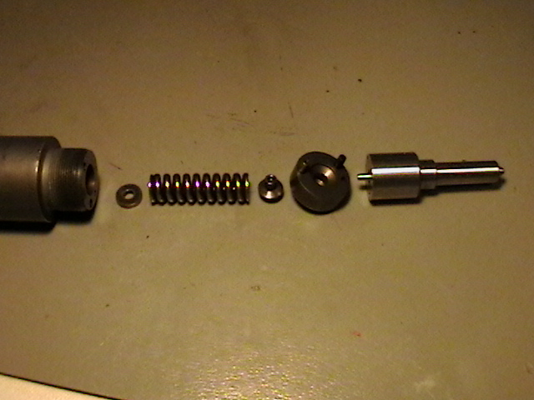

Retighten the injector to 28ft lbs. Repeat to the other five injectors. Then ship off to your injection shop so they can properly shim and make sure the nozzles atomize right.

Chapter 2:

- How new injector nozzles affect popping pressure

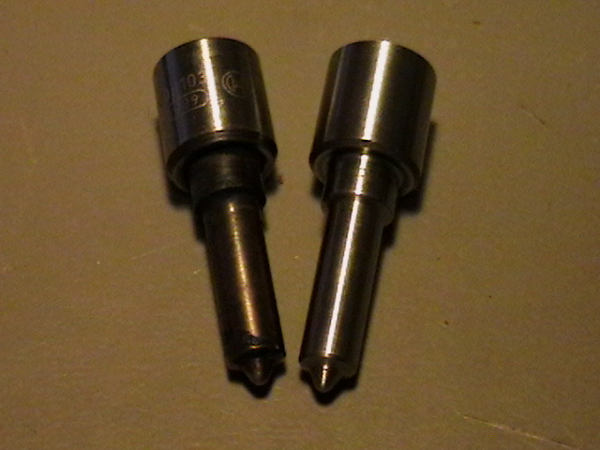
These nozzles are for a 98.5-02 24v Cummins, One nozzle has about 120k miles on it and the other one is new.

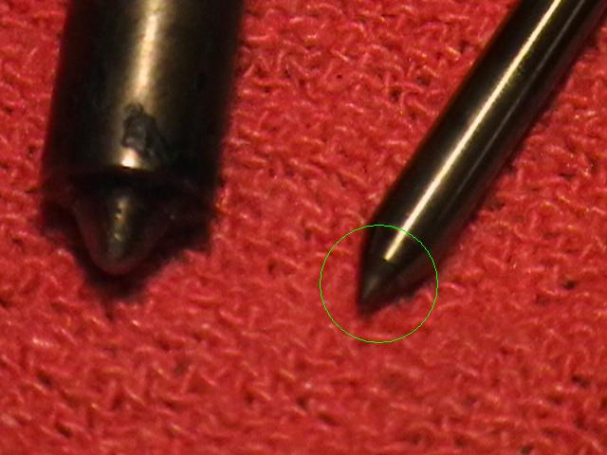
Notice how on the used nozzle has wear rings.

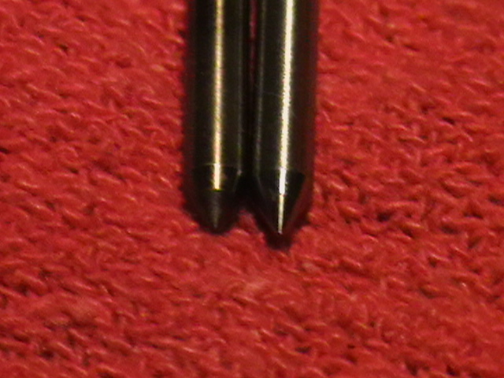
The new one of course doesn’t have the wear rings.

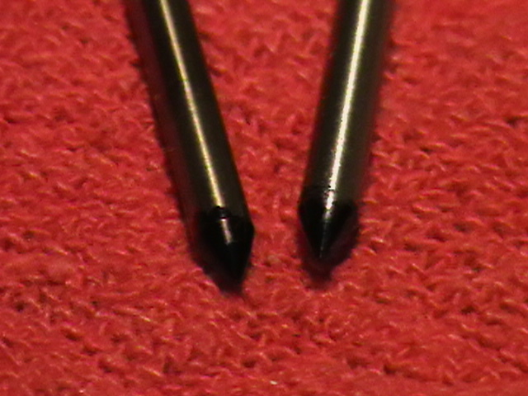
I took a sharpie and drew on the end of the plunger to show how 120k mile plunger compares to a new one.

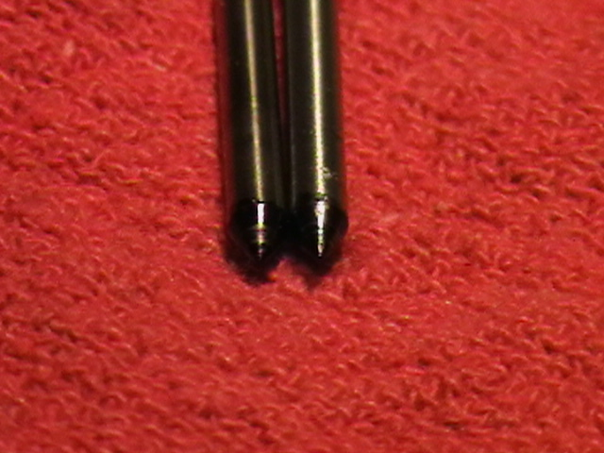
After placing each plunger in each nozzle and turning it a couple times you will see that the used nozzle had a lot of wear. I would say that a lot changes over in your injectors over the course of 120k miles. Could you imagine having a metal being slammed up against another metal with 4500psi pushing on it and going at a rate of 800-3500rpm?

Chapter 2a:

- Measuring of the nozzles

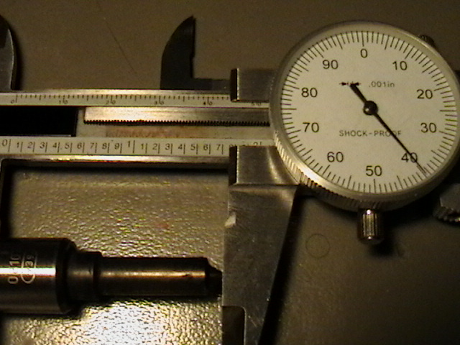
The used nozzle is 1.74 inches long

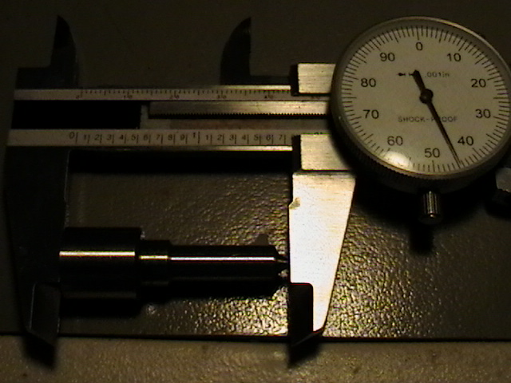
The new nozzle has a length of 1.745 inches long. That .005in difference.

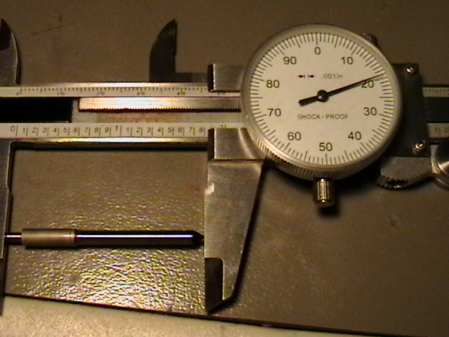
The used plunger measures 1.819in long

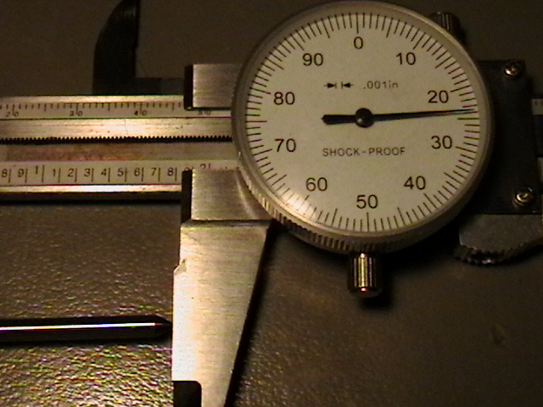
The new plunger measures 1.824in. The plunger length compared to the used injector nozzle makes the greatest impact on changing the injector pop pressure.

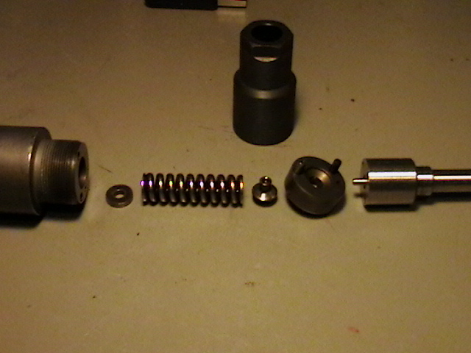
The spring sits on top of the end of the plunger so any change of the plunger would make a big difference in change of pop pressure. It is HIGHLY recommended getting your injectors shimmed to the correct pop pressure and so that you know that your injector doesn’t have an off spray or not atomizing properly. Not having a proper atomizing injector can result in serious damage and not having a injector pop when it is suppost to will hamper mileage, make your truck sound different, and having the fact that your truck or tractor doesn’t run right.

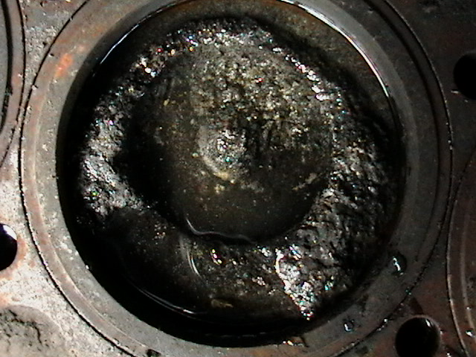
Here’s a picture of someone that didn’t care what the spray pattern was or the pop pressure (and yes that’s suppost to be a piston). Which one would you rather have?

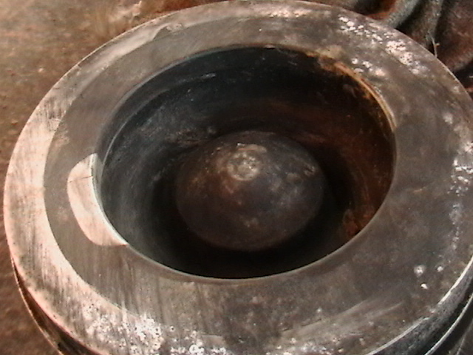

Chapter 3:

- What the injection shop is going to do with your injectors

First when we/they receive your injectors they will go right to the pop testing stand and will be pop-tested so we/they will get an idea of how big of a shim they will need to make the injector pop to about 310bar (4500psi).

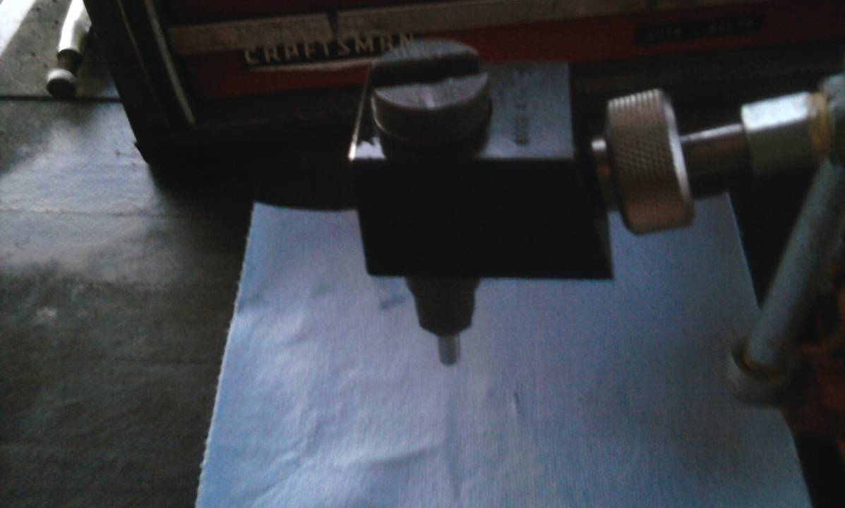

They will most likely have to take the injector apart several times to get the pressure to about 4500psi (sorry for the bad picture its kind of hard to hold the camera still and push down on a leaver that shakes when the Injector pops).

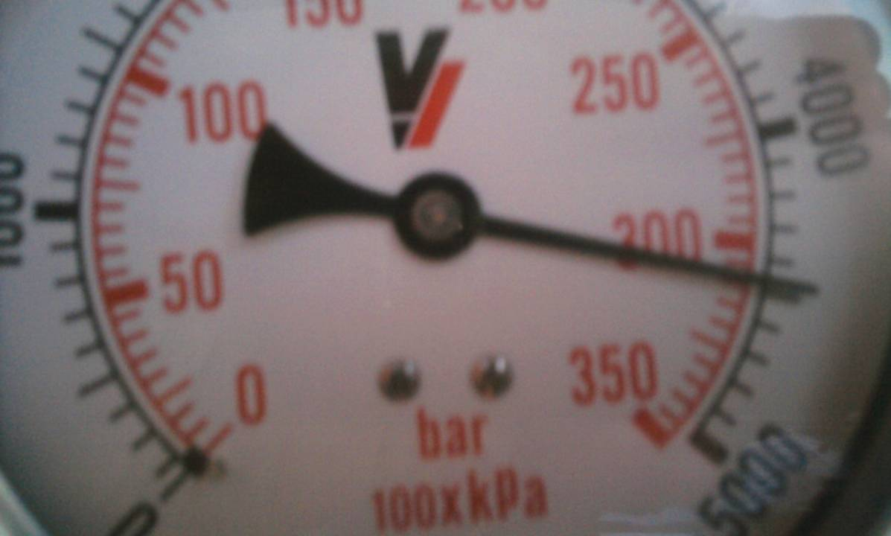

When they are all shimmed and set to in the neighborhood of 310bar (4500psi) they will be shipped out and you will get them in 2-3 days.

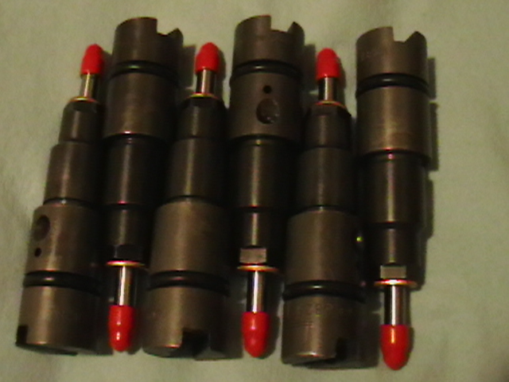

If you want me to add anything or if you have any questions pm me or call me at 812-603-3546 (till 10pm est)



